CRICKET PLAYER PERFORMANCE TRACKING APPLICATION :CRICKSTATS

NAME : K.Rokini
COLLEGE : C. Kandaswami Naidu College for Women, Cuddalore
DEPARTMENT : B.Sc. Computer Science
YEAR : Final Year
REGISTER NUMBER : 24131021802522040
NMS NUMBER : c225463e562b879bb1048637cda98cac@nm2026
1. INTRODUCTION
CRICKSTATS is a Salesforce-based application developed to manage and track cricket player performance. It stores player details and match-performance records in one centralized system.
The application uses Salesforce features such as custom objects, fields, relationships, formula fields, roll-up summaries, Lightning App, and Screen Flow. It helps calculate player statistics and display player information easily.
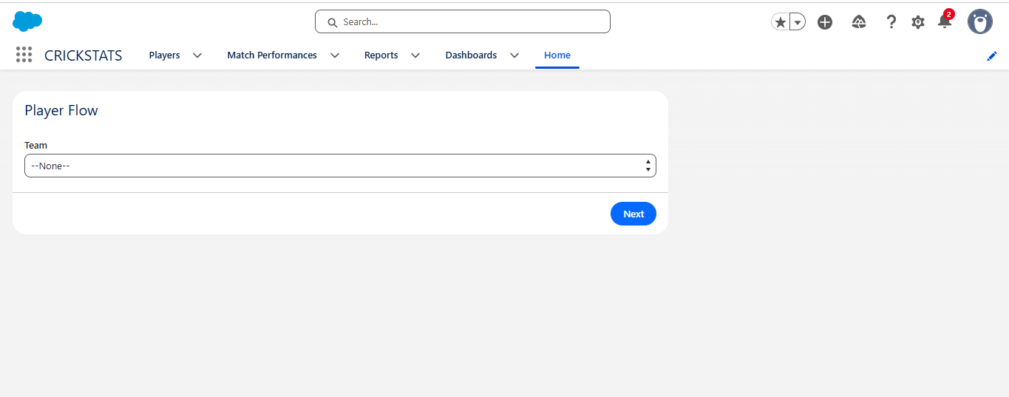

2. PROBLEM STATEMENT
Managing cricket player information and match-performance records manually can be difficult when the number of records increases. Player details and performance data may be stored separately, making it difficult to quickly view a player's overall performance.
Manual calculation of statistics such as total runs, matches played, fours, sixes, wickets, and catches can also take more time and may lead to calculation errors. There is a need for a centralized system that can store player information, maintain match-performance records, and display calculated statistics in an organized way.

3. SOLUTION
The CRICKSTATS application provides a Salesforce-based solution for managing cricket player performance. It stores player details and match-performance information in a centralized system.
The application uses Salesforce objects, fields, relationships, formula fields, and roll-up summary fields to organize and calculate player statistics. The Player Flow allows users to select a team and view the related player information and performance statistics.
This solution reduces manual calculation, provides easy access to player information, and makes cricket performance records easier to manage and view.

2. OBJECTIVES
- To maintain cricket player information.
- To record match-performance details.
- To calculate player statistics automatically.
- To connect player and match-performance records.
- To provide a simple and organized user interface.
- To display player information using Flow.
- To reduce manual calculation and data management.

3. PHASES OF DEVELOPMENT

PHASE 1: REQUIREMENT ANALYSIS AND PLANNING
In this phase, the requirements of the application were identified. The main requirement was to create a system for storing player details, match-performance records, and calculating player statistics.
Salesforce was selected as the development platform. The project was planned using objects, fields, relationships, roll-up summaries, Lightning App, and Flow.
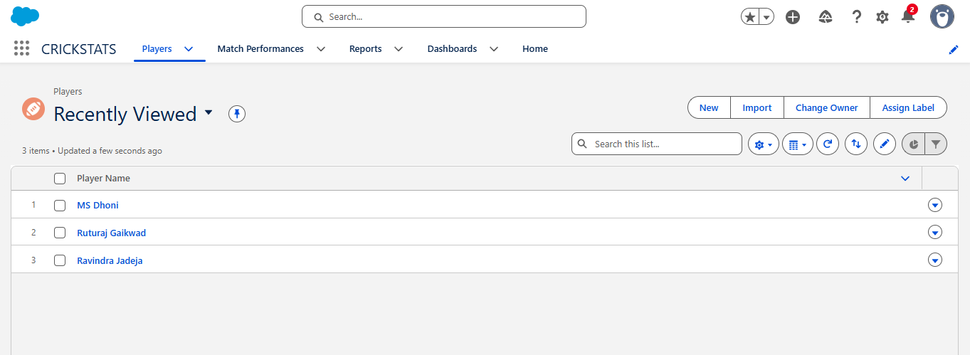
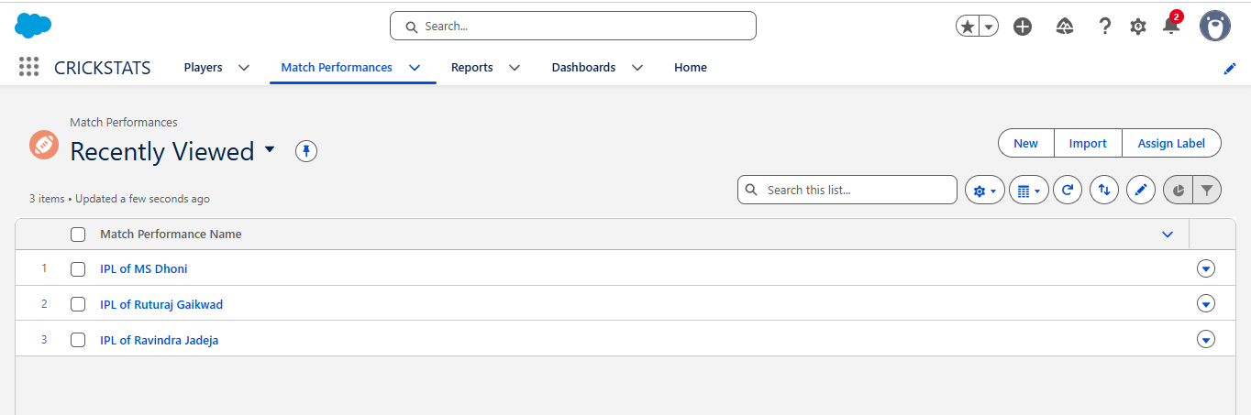

PHASE 2: SALESFORCE DEVELOPMENT – BACKEND AND CONFIGURATION
The main backend components were created in Salesforce.

Player Object
The Player object stores details such as:
- Player Name
- Player Number
- Role
- Batting Style
- Bowling Style
- Nationality
- Team
- Average Score

Match Performance Object
The Match Performance object stores:
- Runs Scored
- Balls Faced
- Fours
- Sixes
- Overs Bowled
- Wickets Taken
- Catches
- Match Result
A relationship was created between Player and Match Performance.
Roll-up summary fields were also created to calculate values such as total runs, matches played, fours, sixes, wickets, and catches.
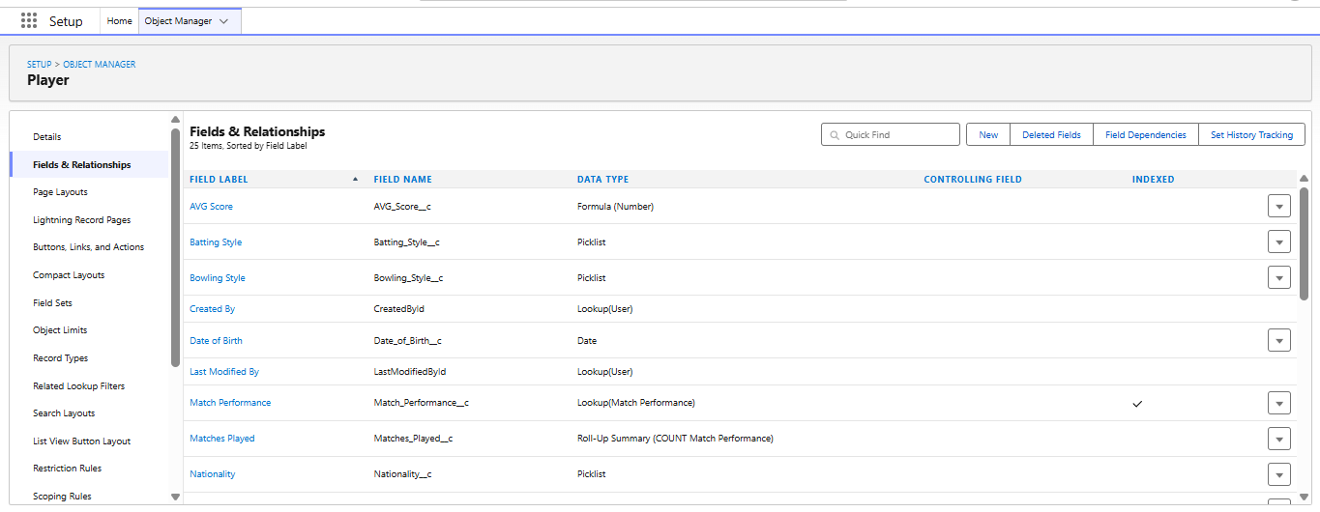
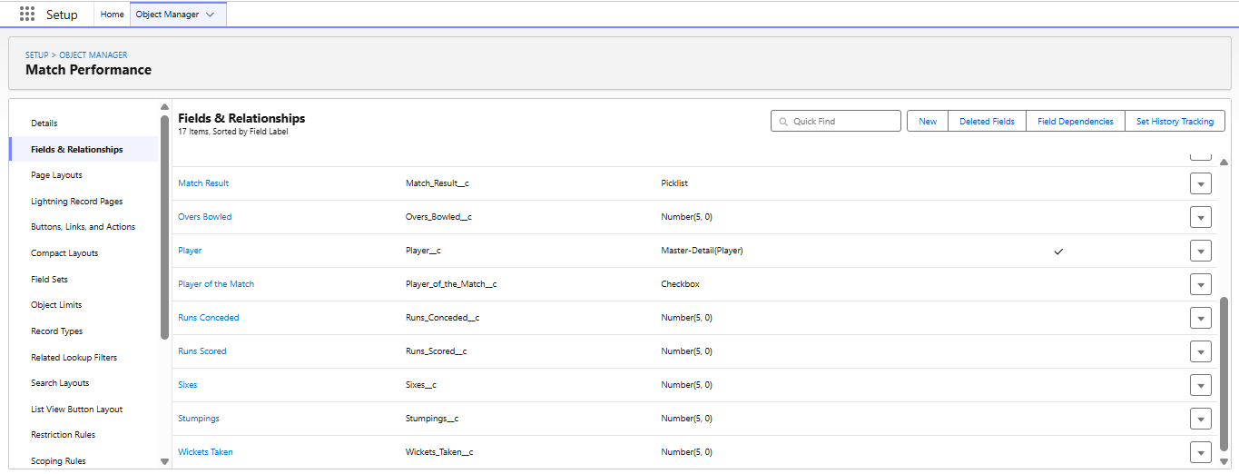

PHASE 3: UI/UX DEVELOPMENT AND CUSTOMIZATION
Custom tabs were created for Player and Match Performance.
A Lightning App named CRICKSTATS was created to provide easy access to the application components.
A Screen Flow named Player Flow was also created. The user can select a team, and the Flow displays the related player information and statistics.
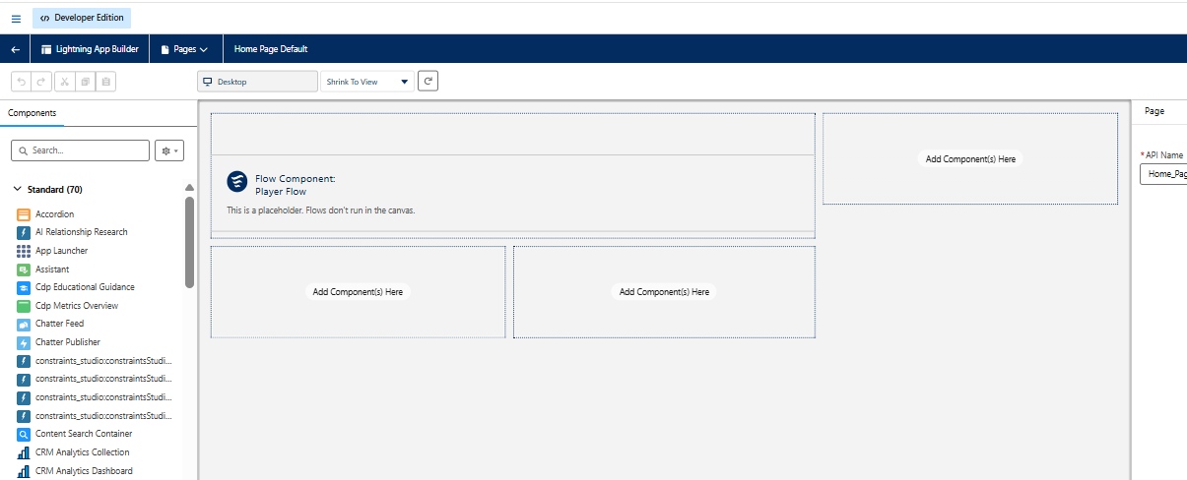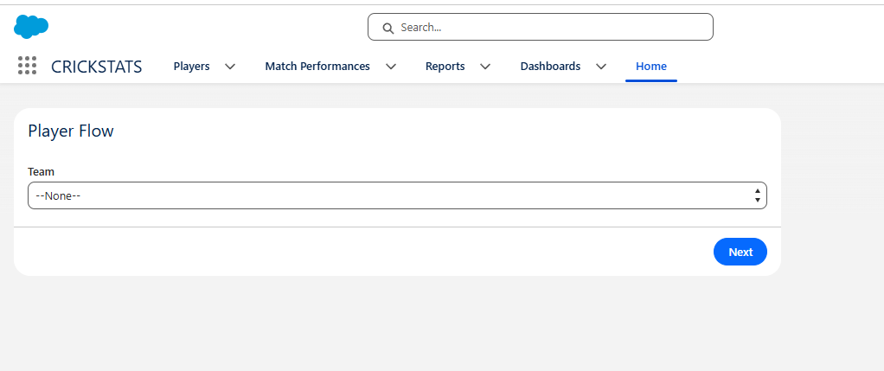

PHASE 4: DATA MIGRATION, TESTING AND SECURITY
For the completed project, three player records and related Match Performance records were entered into Salesforce.
The application was tested by checking player records, match-performance records, relationships, calculated statistics, and the Player Flow.
The Salesforce environment also provides access-control and permission features to help protect application data.

player records: Match Performance
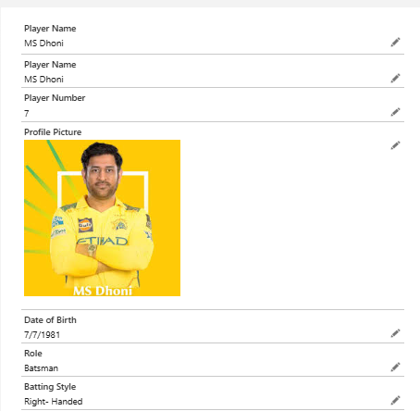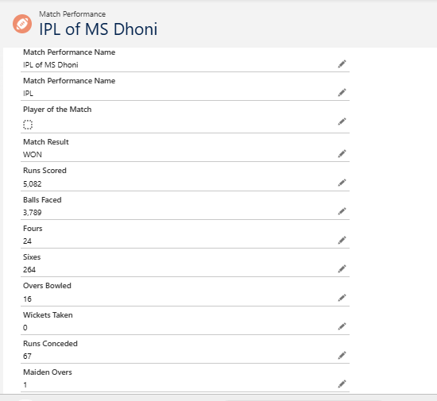

PHASE 5: DEPLOYMENT, DOCUMENTATION AND MAINTENANCE
The CRICKSTATS application was completed and is currently working in the Salesforce environment.
The completed system was checked to ensure that the main features were functioning correctly. Documentation was prepared to explain the project, development phases, features, and results.
The application can be maintained in the future by adding new players, match records, fields, and additional features when required.
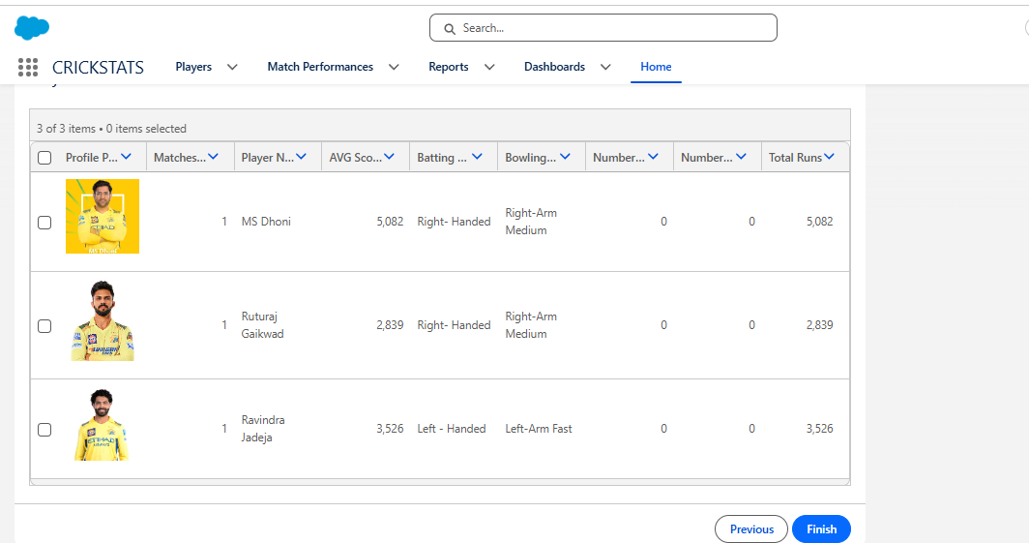

4. ADVANTAGES AND DISADVANTAGES

Advantages
- Centralized player information.
- Easy management of match records.
- Automatic calculation of statistics.
- Reduces manual work.
- Easy access to player information.
- Can be extended with additional features.

Disadvantages
- Requires Salesforce access.
- Internet connection is generally required.
- Limited offline access.
- Depends on the Salesforce platform.

5. CONCLUSION
The Cricket Player Performance Tracking Application: CRICKSTATS was successfully developed using Salesforce. It provides an organized system for managing player details and match-performance records.
The project demonstrates the use of Salesforce objects, fields, relationships, formula fields, roll-up summaries, Lightning App, and Flow. Three player records and their performance information were added and tested successfully.
Overall, the project provided practical knowledge of Salesforce development, data management, application configuration, Flow creation, and testing.

